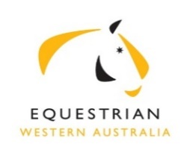 | Summary of Business  Excerpts from the Minutes of the EWA Board Meeting  held at 6.30pm on 28 May 2019 at SEC, Brigadoon

Present: R Fleming (Chair), W Newton-Wordsworth (Vice Chair), K Van Eykelenborg (Finance
Director), A Avery, L Barnes, A Marchesani
Apology: A Wilkins In attendance: A Ridzuan-Bottrell (EWA Communications) D Pedlow (CEO)

The Minutes of the meeting of 30 April 19 were approved with minor amendment.

General Business

Chair welcomed EWA staff member Aiman Ridzuan-Bottrell to the meeting to report on current EWA social media policy, procedure and plan. Aiman to develop updated Social Media Policy for review by Board.

SEC Operational shortfall strategy of engagement with DLSCI, letter to be written to Director General requesting funding shortfall. CEO to also engage with City of Swan and Local state member Jessica Shaw

EWA Constitutional matters were discussed by the Board. The Jumping committee was reinstated.

Sport committee KPI to be reviewed

Financial reports for April 19 were circulated prior to meeting and accepted by Board.

Operational Business

CEO Report tabled and activity noted by Board.

There were no OSH/Risk Management matters discussed.

With no further business, the Meeting closed.
Next meeting scheduled for Tues 25 June 19.

