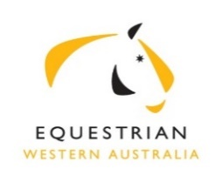 | Summary of Business  Excerpts from the Minutes of the EWA Board Meeting  held at 6.30pm on 2 September 2019 at SEC, Brigadoon

Present: : R Fleming (Chair), W Newton-Wordsworth (Vice Chair), A Avery, L Barnes,
A Marchesani, A Wilkins )

In attendance: D Pedlow (CEO) K Doolan (Minutes)

The Minutes of the meeting of 6 August 2019 were approved with no changes.

General Business

SEC Operational shortfall meeting is planned with Director General DLGS, City of Swan CEO and Department of Sport staff to discuss SEC Operational shortfall and redevelopment

EWA Constitutional only one Sport committee provided feedback.

Sport Committee KPI draft presented.

Succession Planning in regard to Committee representatives, skills, time lines to be identified.

Gidgegannup Incident CEO updated on current situation.

Next EA CEO face to face meeting to be held in Perth.

Jumping committee re use of Global instead of Nominate re Jumping Championship.

Financial reports for September 2019 were circulated prior to meeting and accepted by Board.

Potential Finance director to be approached.

Carl Hester event discussed

Operational Business

CEO Report tabled and activity noted by Board.

There were no OSH/Risk Management matters discussed.

With no further business, the Meeting closed.
Next meeting scheduled for Tuesday 1 October 2019.

