Show Horse WA High Performance Squad

Application Form

2023

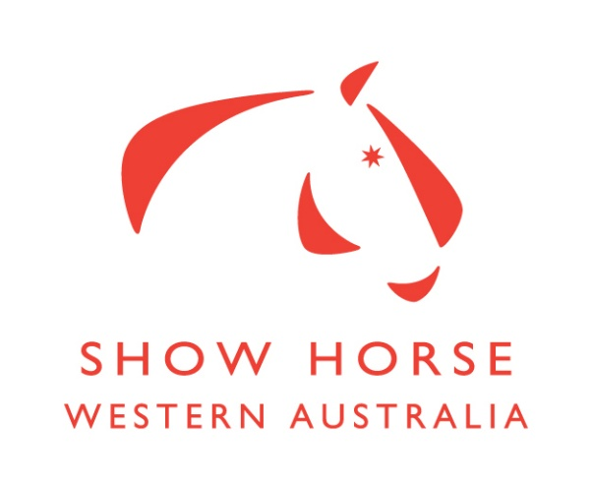

Please read the Selection Criteria before submitting this Application Form
Note: Applicants must be current members of EWA & Horses Registered
All of the details below MUST be completed for your application to be accepted

Riders Name: DOB:
EWA M/Ship Number: | Current Coach:
Rider/Parent/Guardians Name(s):
Address: |  | Post Code:
Home Phone: | Work Phone:
Mobile Phone: | Email address:

Nominated Horse 1: | Date of Birth:
EA Number: | Height:

2nd Nominated Horse (if applicable): | Date of Birth:
EA Number: | Height:

Combination One’s three (3) best recent performances at EWA Shows in the 12 months prior to this application:  (In combination with nominated horse)  Please supply a copy of your Competition license in the current year | Venue | Date | Class | Placing

Combination One’s three (3) best recent performances at Non-EWA Shows in the 12 months prior to this application:  (In combination with nominated horse)  Please supply a copy of your Competition license in the current year | Venue | Date | Class | Placing

Combination Two’s (If applicable) three (3) best recent performances at EWA Shows in the 12 months prior to this application closing date:  (In combination with nominated horse)  Please supply a copy of your Competition license in the current year | Venue | Date | Class | Placing

Combination Two’s (If applicable) three (3) best recent performances at non-EWA Shows in the 12 months prior to this application closing date:  (In combination with nominated horse)  Please supply a copy of your Competition license in the current year | Venue | Date | Class | Placing

Have you attended a clinic/clinics in the last 12 months?

If so, with which instructor?

Coach/Instructor | Date | Venue | Clinic Objectives

General Questions
(Please answer the below questions with as much detail as possible to assist the Selection Panel in their selection)

- What is your motivation in applying for the Equestrian WA High Performance Program?

- In relation to the High Performance pathway:
- What are you short term competition goals?

- What are you long term competition goals?

- What is your current training schedule (Please include coaches names and frequency of lessons)?

- Do you assist or volunteer in any EWA Show Horse events? If so, please state which events.

Riders are reminded that participating in Show Horse High Performance Squads is a privilege, not a right. These privileges are withdrawn if riders do not follow the Code of Conduct.

I understand that, if my application for inclusion in the EWA High Performance program is successful, that I agree to attend a minimum number of workshops/clinics offered as part of the High Performance Program, and will be subject to my reading, understanding, signing, and abiding by the Equestrian Western Australia High Performance Squad Code of Conduct. By signing this application I consider myself and my horse medically fit to compete and accept that EWA has no responsibility for my fitness. If successful, a communication will be sent advising of your invitation onto the squad. Your placement onto the squad shall be conditional upon your acceptance in writing within 7 days thereof.

Signature: _______________________ Date: _________________

Signature of parent or guardian (if rider under the age of 18):

_______________________ Date: _________________

Please return your application form to the Equestrian WA High Performance Manager by emailing highperformance@equestrianwa.org.au

STANDARD SQUAD MEDICAL FORM
PRIVATE AND CONFIDENTIAL

NAME: _________________________________________________ AGE (if under 17yrs):__________
ADDRESS: _______________________________________________________________________
_________________________________________________________________________________
_________________________________________P/CODE: ________________________________
PHONE: ________________________________________
EMERGENCY CONTACT
NAME: _______________________________ PHONE: _________________________________
AMBULANCE SUBSCRIBER Yes ____ No ____
MEDICARE N0. _______________________ PRIVATE COVER____________________________
DOCTORS NAME: _______________________PHONE: _________________________________
Please tick if you suffer from any of the following:
____ Asthma (please list medication) _________________________________________________
____ Heart Problems
____ Tiredness/Fatigue
____ Allergies (please list allergies) ___________________________________________________
____ Diabetes (please list medication) _________________________________________________
____ Back Problems (please list) _____________________________________________________
____ Operations in the last 12 months (please list) _______________________________________
____ Any other medical history we should be aware of (please list) __________________________
_______________________________________________________________________________
_______________________________________________________________________________

EA General Code of Conduct
All EA Member or persons required to comply with the EA Member Protection Policy must meet the following requirements in regard to their conduct and behaviour during any activity held or sanctioned by EA, and in any role held within EA or any of its affiliates:
- Respect the rights, dignity and worth of others.
- Be fair, considerate and honest in all dealing with others.
- Be professional in, and accept responsibility for, your actions.
- Make a commitment to providing quality service.
- Be aware of, and maintain an uncompromising adhesion to EA standards, rules, regulations and policies.
- Scrupulously avoid any conduct using privileged information to gain a personal or commercial advantage.
- Operate within the rules of the sport including national and international guidelines which govern Equestrian Sport, the member associations and the affiliated clubs.
- Do not use your involvement with EA, its member associations or affiliated clubs to promote your own beliefs, behaviours or practices where these are inconsistent with those of EA.
- Demonstrate a high degree of individual responsibility especially when dealing with persons under the age of 18 years, as your words and actions are an example.
- Avoid unaccompanied and unobserved activities with persons under the age of 18 years, wherever possible.
- Refrain from any form of harassment of others.
- Refrain from any behaviour that may bring EA, its member associations or affiliated clubs into disrepute.
- Provide a safe environment for the conduct of the activity.
- Show concern and caution towards others who may be sick or injured.
- Be a positive role model.
- Understand the repercussions if you breach, or are aware of any breaches of this Member Protection Policy.

Signature: _______________________ Date: _________________

EA Code of Conduct for Competitors
In addition to the EA General Code of Behaviour, participants must meet the following requirements during any activity held or sanctioned by EA or one of its affiliates:
- Abide by the principles of the FEI Code of Conduct for the Welfare of the Horse.
- Respect the rights, dignity and worth of fellow athletes, coaches, officials, volunteers and spectators.
- Do not tolerate acts of aggression.
- Respect the talent, potential and development of fellow athletes and competitors.
- Care for and respect the equipment provided to you as part of your program.
- Be frank and honest with your coach concerning illness and injury and your ability to train fully within the program requirements.
- At all times avoid intimate relationships with your coach.
- Conduct yourself in a professional manner relating to language, temper and punctuality, be courteous, kind and always set a good example in dress and behaviour.
- Maintain high personal behaviour standards at all times.
- Abide by the rules and respect the decision of the official, making all appeals through the formal process and respecting the final decision.
- Be honest in your attitude and preparation to training. Work equally hard for yourself and your team.
- Cooperate with coaches and staff in development of programs to adequately prepare you for competition at the highest level.
- Understand the repercussions if you breach, or are aware of any breaches of this Member Protection Policy.

Signature: __________________ Date: _____________

