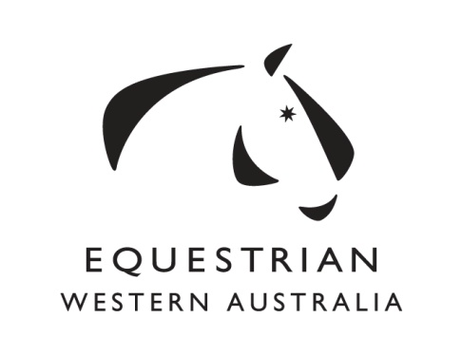
303 Cathedral Avenue, Brigadoon WA 6069
Phone: (08) 9296 1200 Fax: (08) 9296 1194 Email: ceo@equestrianwa.org.au

DRESSAGE WA AFFILIATE REPRESENTATIVE NOMINATION FORM
To be returned to the EWA Office by no later than 5.00pm Thursday 13th October 2016.

I, ___________________________________________ wish to nominate

_________________________________________________________

for the position of

AFFILIATE REPRESENTATIVE
on the

DRESSAGE WA COMMITTEE

Of Equestrian Western Australian Inc.

Signed: _______________________________ EWA #: __________________

I, _______________________________ accept the nomination and, in doing so, verify that I am conversant with the Constitution, EWA and EA policies and procedures, rules and regulations of the Equestrian WA Incorporated as approved by the Board from time to time. I understand the responsibilities which I undertake to carry out in the best interest of the Equestrian WA Incorporated. I acknowledge I have read and understand the information below and that nominations must be received by the EWA Office no later than 5.00pm Thursday 13th October 2016.
Address: ______________________________________________________________________
Phone : _____________________________________
Email: ______________________________________
Occupation: __________________________________
Signed: ______________________________________ EWA #: ____________________

I, ________________________________________ hereby second the nomination.

Signed: ______________________________________ EWA #: ____________________

ELECTION PROCEDURE

- Nominations shall be returned to the Chief Executive Officer of EWA by post, email or fax as per the details above. The CEO shall act as the Returning Officer.
- It is the responsibility of each individual signing this form to ensure they are eligible financial members of EWA and to ensure the form is received by the Returning Officer prior to the closing of nominations. Any nomination will be deemed invalid if it fails to meet either of the above requirements.
- Every nomination must be accompanied by a resume of the nominee comprising not more than two hundred (200) words. In the event that any resume so provided exceeds two hundred (200) words, the CEO may elect to disregard the resume altogether as if it had not been received. The resume should include the following:
- Previous EWA Committees
- Committee responsibilities undertaken
- Reason/objectives of the nominee
- Equestrian history
- Business experience
- General comments
303 Cathedral Avenue, Brigadoon WA 6069
Phone: (08) 9296 1200 Fax: (08) 9296 1194 Email: ceo@equestrianwa.org.au

RESUME FORM
To be returned to the EWA Office by no later than 5.00pm Thursday 13th October 2016.

Name:

Equestrian interest:

Previous Board / Committee experience:

Reason / objectives for interest in representing EWA on the Dressage WA Committee:

Equestrian history:

Business experience:

General comments:

