EWA High Performance Program

Aim - The EWA High Performance aims to identify talent and offer supporting education to Squad riders at a developmental level with ambitions to follow pathways to National Selection

Our Mission is to offer a High Performance program that:

- Identifies and develops athletes with the aspiration and potential to succeed in National and International competition
- Offers clear pathways for athletes to move between these groups
- Will significantly improve the success of aspiring HP athletes within WA.
- Maximises the effective use of limited funds available
- Support clear pathways promoting Coach and Officials Development from State through to National and International accreditation standards.
Horse and rider combination’s best five (5) performances in last 6 months (December 2021 to July 2022)
Venue | Date | Class | Faults |  | Placing
 |  |  | Round 1 | Round 2
 |  |  | Round 1 | Round 2
 |  |  | Round 1 | Round 2
 |  |  | Round 1 | Round 2
 |  |  | Round 1 | Round 2

Values
- To create a high performance program that aligns disciplines and offers the highest possible opportunities for education and development of athletes on the high performance pathway
- Deliver and grow the Equestrian Western Australia High performance program with honesty, integrity, professionalism, discipline, passion and respect

EQUESTRIAN WA HIGH PERFORMANCE JUMPING SQUAD EXPRESSION OF INTEREST
All of the details below must be completed for your application to be considered.
PLEASE PRINT CLEARLY AND COMPLETE ONE EOI FORM PER HORSE
Riders Name |  |  |  | EA Number
Horse Name |  |  |  | EA Number
Horse DOB |  |  | Level Currently Competing
Squad EOI for |  | STATE RECOGNITION YOUTH
Date of Birth (if under 25)
Postal Address
Suburb |  |  |  | Post Code
Home Phone |  |  |  | Mobile Phone
Email address |  |  |  |  |  | Squad Shirt Size

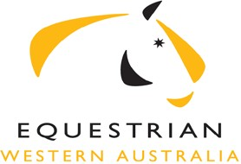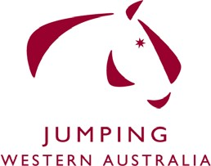

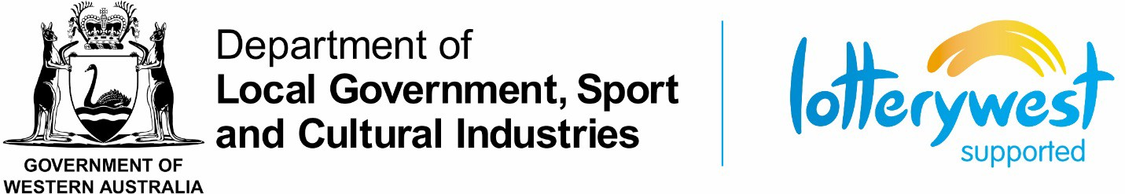

General Questions (please answer the below questions with as much detail as possible to assist the Selection Panel in their selection)
1) What is your motivation in applying for the Equestrian WA High Performance Program?
- In relation to the high performance pathway:
  - What are you short term competition goals?

  - What are you long term competition goals?
3) What is your current training schedule (Please include coaches names and frequency of lessons)?

I understand that, if my application for inclusion in the EWA High Performance program is successful, that I agree to attend a minimum of ## workshops/clinics offered as part of the High Performance Program, and will be subject to my reading, understanding, signing, and abiding by the Equestrian Western Australia High Performance Squad Code of Conduct. By signing this application I consider myself and my horse medically fit to compete and accept that EWA has no responsibility for my fitness. A communication will be sent advising of your invitation onto the squad. Your placement onto the squad shall be conditional upon your acceptance in writing within 7 days thereof.

Signature of applicant: Date: / /

Signature of parent or guardian (if rider under the age of 18): Date: / /

Please return your expression of interest to the EWA Sport Development Manager, Kaeleigh Brown by emailing development@equestrianwa.org.au

303 Cathedral Avenue BRIGADOON WA 6069

