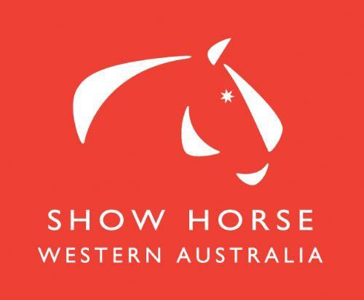
2020 SHOWHORSE INFORMATION BOOKLET

Edition reviewed 23 January 2020

SHOW HORSE HANDBOOK 2020

Our Vision 3
Our Principal Objectives 3
Preamble 3
Leaderboard Championship Series ……………………………………………………………………………………………………………….3
Triple Crown Award ……………………………………………………………………………………………………………………………………..3
Horse Welfare 5
FEI Code of Conduct for the Welfare of the Horse 5
Officials 5
National Show Horse Committee 5
Glossary / Definitions for Novice, Intermediate, Rural Horses & Newcomer 6
Map of Rural Horse Competition Area 7
Rural Rider ……………………………………………………………………………………………………………………………………….7
EWA Show Horse Competitions 2020 8
National and State Horse of the Year ………………………………………………………………………………………………………….. 9
State Horse of the Year Qualifications 10
Helmets ………………………………………………………………………………………………………………………………………………………11
Judging Scheme 11
Measuring Scheme 11
Information for Event Organisers 12
National Judges Accreditation Scheme 12
Judges ………………………………………………………………………………………………………………………………………………………..12

Our Vision

To have an active Show Horse community with increasing participation in a professionally run sport where all members have the opportunity to compete safely at a variety of levels.

Our Principal Objectives

- To provide effective governance to maintain a position of leadership and influence within the WA Show Horse community.
- To maintain professional and prestigious events to ensure a vibrant competition environment for all levels.
- To promote the highest ideal of sportsmanship and to provide benefits for members of all levels to be involved in show horse competition.
- To develop high quality Coaches and Officials.
- To improve communications within the EWA, its members and the broader community.
- To encourage riding and Show Horse as a sport and recreation. To promote good fellowship among riders and to improve and maintain the standard of riding and horse mastership.

Preamble

This information booklet has been revised to gather the rules and guidelines from many aspects of the sport of Show Horse, into one resource. It is important that all involved in the sport know the rules under which they compete. As well, organizers and volunteers must be aware of their responsibilities and entitlements. This booklet will be a key source of knowledge. Competitors, officials and volunteers will be advised of updates to this handbook, during the year, via the EWA Newsletter.

Please note: There have been CHANGES to the National Show Horse Rules, EFFECTIVE 1ST JANUARY, 2020. Please refer to the National Rules.

A Leaderboard CHAMPIONSHIP Series will be run during 2020 with affiliated clubs applying for funding to hold championship events. These events MUST BE run under EA rules with an accredited EA Judge officiating. Results from clubs running these events together with results from the EWA run Autumn Pageant, Winter Gala and Horse of the Year will count towards the Leaderboard points. Further details will be advertised on the Showhorse Facebook page, EWA Newsletter and website as they become available.

2020 Triple Crown Cash Award

A cash award will be presented to any horse/pony that is awarded a Champion at all 3 EWA run shows during 2020 in open show horse and show hunter classes.
These shows are:
- Autumn Pageant
- Winter Gala
- Horse of the Year
A $1000 cash prize will be on offer to be split evenly between any winners.
- If only 1 horse/pony wins champion at all three shows winner takes all.
- If multiple horses/ponies win champion at all three shows prize money will be divided equally amongst the winners.
- If no horse/pony wins champion at all three shows no prize money will be awarded.
- The award is presented to the owner/s of the horse of pony

Classes which count are:
- Combined Lead Rein Show Pony & Show Hunter Pony
- Champion Small Show Pony
- Champion Small Hunter Pony
- Champion Medium Show Pony
- Champion Medium Hunter Pony
- Champion Large Show Pony
- Champion Large Hunter Pony
- Champion Small Show Galloway
- Champion Small Hunter Galloway
- Champion Large Show Galloway
- Champion Large Hunter Galloway
- Champion Small Show Hack
- Champion Small Hunter Hack
- Champion Large Show Hack
- Champion Large Hunter Hack

Awards will be presented to any winner/winners at the EWA Awards Night.

EWA Show Horse Events. All events will be run by the EWA Show Horse Committee. Information will be available via the EWA Newsletter, FB page OR at www.equestrianwa.org.au click on NEWSFLASH.
PROGRAMS & ENTRY FORMS CAN BE DOWNLOADED FROM CAVALLETTI AND/OR NOMINATE AS THEY BECOME AVAILABLE

https://www.facebook.com/EquestrianWAShowHorse/

Horse Welfare

FEI Code of Conduct for the Welfare of the Horse:

The Fédération Equestre (FEI) expects all those involved in international equestrian sport to adhere to the FEI’s Code of Conduct and to acknowledge and accept that at all times the welfare of the horse must be paramount and must never be subordinated to competitive or commercial influences.

At all stages during preparation and training of competition horses, welfare must take precedence over all other demands. This includes good horse management, training methods, farriery, tack and transportation.

Horses and competitors must be fit, competent and in good health before they are allowed to compete. This encompasses medication use, surgical procedures that threaten welfare or safety, pregnancy in mares and the misuse of aids. Competitors should refrain from excessive pre-event lunging.

Events must not prejudice horse welfare. This involves paying careful attention to the competition areas, ground surfaces, weather conditions, stabling, site safety and fitness of the horse for onward travel after the event.

Every effort must be made to ensure that horses receive proper attention after they have competed and that they are treated humanely when their competition careers are over. This covers proper veterinary care, competition injuries, euthanasia and retirement. The FEI urges all involved with the sport to attain the highest levels of education in the areas of expertise.

Officials

Equestrian WA Show Horse Committee 2020

Name | Number | Email Address:
Val Mayger (Chair) | 0417 991364 | vmayger@bigpond.net.au
Kerry Wilson | 0417 170894 | kerrywilson104@gmail.com
Marlene Kinder | 0419 418145 | marlenekinder@yahoo.com.au
Lindsay Baxter | 0409 200161 | lindsaybaxter6055@gmail.com
Jane Fisher | 0412 203092 | hypofish@hotmail.com
Bernie Jenkinson | 0411 157917 | Bernard.jenkinson@network.pmc.gov.au

Measuring
Debbie King | 0417 186906 | Dking54@bigpond.com

National Show Horse Committee 2020

Position | Name | Phone | Email Address
National Chair | Kerry Patchett | 0412 062084 | kpatchett@so.com.au
Western Australian Delegate | Kerry Wilson | 0417 170894 | kerrywilson104@gmail.com
Rider’s Representative | Chris Lawrie | 0418 852712 | ridersrep@outlook.com

Glossary / Definitions

Novice

Horse/pony that has not won more than three first placings in an open official show horse or show hunter class.

Intermediate
An Intermediate horse or pony is one that has not been judged Champion or Reserve Champion in any show horse or show hunter classes at –
- ANY Royal Show (including Novice classes)
- ANY EA State Horse of the Year
- ANY SHC State Horse of the Year
- ANY previous Intermediate Horse of the Year winner or runner up
- EA National Show Horse and Rider Championships
- SHC Grand Nationals

This includes Champions and Reserves in Child’s show horse or show hunter classes at any of the above shows.

Newcomer
CONDITIONS OF ENTRY SPECIFIC TO NEWCOMER EVENT
A horse/pony that has not competed under saddle (with the exception of Racing) in any State/Territory prior to the start of the Qualifying period determined by each State/Territory in which the horse resides and is registered. This includes any Pony Club competition. A Pony that has only competed in Leading Rein or Miniature Turnouts and has not competed off the lead is eligible to be considered a Newcomer.
A horse/pony that has competed in breed classes under saddle is not eligible to be considered a Newcomer.
- The horse must be registered with the EWA at the time of qualifying.
- The horse must have a current EWA Height Certificate at the time of qualifying.
- The horse must be shown in a snaffle bridle.
- The horse may compete in the relevant State HOTY event as its first competition.
- The horse may compete in the Open section at the HOTY subject to State/Territory qualifying rules where applicable.
- Any horse or pony, having competed interstate or internationally during this period, will be required to provide proof of eligibility. Horses arriving from interstate or internationally must provide details of performances to the Show Horse Committee, prior to the Newcomer license being issued.
- Owners and Riders must be current EWA financial members, at the time of qualifying.
- Horses/Ponies must have a current Newcomer Licence card at the time of qualifying.
- Horses/ponies are not eligible to enter if they have competed outside the qualifying period.
- Horse/pony must be domiciled in WA for a total minimum period of three months and 1 day during the twelve months immediately preceding the day of the show.
- Stallions are not eligible to compete.

To be eligible horses/ponies must have paid entry fee and competed in at least one class at any official show horse or show hunter fixture in their appropriate class (excluding rider, Owner/Rider & First Ridden classes) within the qualifying period at an EWA affliated event.. These must be judged by a current EA Accredited Show Horse Judge. In the event of no placing being awarded, the judge or a club official must sign Newcomer licence as proof of competition. Performance licences will be issued by the office and must be returned with entries.

Newcomer Classes 2020

Ponies 12h & under must be ridden by a child 14 yrs and under, ponies over

12h may be ridden by a rider any age, as per National EA Rules
Show Pony 12.2 hands and under must be ridden by rider 14 years and under.
Show Pony over 12.2 hands up to and inc 14 hands ridden by a rider any age. Show Galloway over 14 hands up to and inc 15 hands ridden by a rider any age. Show Hack over 15 hands ridden by a rider any age.

Ponies 12h & under must be ridden by a child 14yrs and under, ponies over 12h may be ridden by a rider any age, as per National EA Rules
Show Hunter Pony 12.2 hands and under must be ridden by rider 14 years and under.
Show Hunter Pony over 12.2 hands up to and inc 14 hands ridden by a rider any age Show Hunter Galloway over 14 hands up to and inc 15 hands rider any age
Show Hunter Hack over 15 hands ridden by a rider any age

QUALIFYING PERIOD FOR 2020 NEWCOMERS
IS FROM CLOSE OF ENTRIES 2019 (29TH May 2019) until close of entries 2020.

ENTRIES CLOSE FOR THE 2019 NEWCOMERS EVENT ON THE SUNDAY 26TH APRIL, 2020

Rural
To be eligible horses/ponies must meet the following criteria;
- Horses/ponies must be domiciled in rural Western Australia for a minimum period of no less than THREE months and 1 day during the twelve months immediately preceding the day of the show.
- Any horse having competed interstate during this period must provide proof of travel dates.
- Horses/ponies must be ridden by rural riders.
- Rural is no less than 85 km’s outside Perth GPO (as per Rural Map).

Map of Rural Horse Competition Area
Please address any queries regarding the boundaries of the map to The Show Horse Committee. (Circle delineates the 85km radius of the GPO Perth)
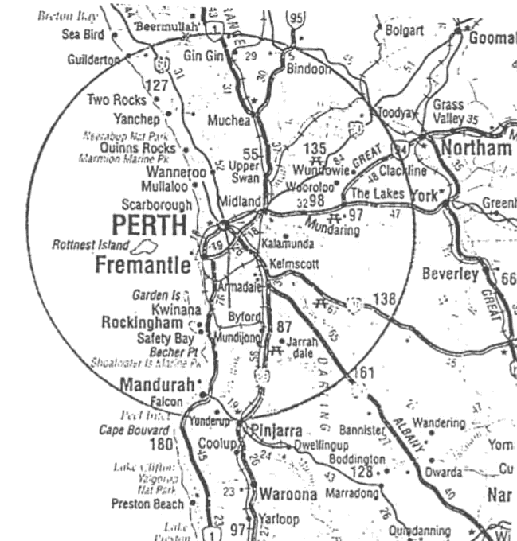

Rural Rider:
- A Rural Rider can board in the city but their actual place of residence must be in the country.

EWA SHOW HORSE COMPETITIONS 2020

EWA AUTUMN PAGEANT 3rd May 2020
STATE EQUESTRIAN CENTRE
Full Hack and Hunter Programme for riders any age
(2021 ENSW Southern Cross Show Horse qualifier)
Owner/Rider classes
OTT classes
Entries Close SUNday 26th April on www.nominate.com.au
EWA MEMBERS ONLY
NO ENTRIES ON THE DAY
NO LATE ENTRIES ACCEPTED
MEASURING AVAILABLE
Points count for Annual EWA Awards
NEWCOMERS &
EWA NEWCOMERS 3 May 2020
STATE EQUESTRIAN CENTRE
Entries Close SUNDAY 26TH April 2020
www.nominate.com.au
NO ENTRIES ON THE DAY
NO LATE ENTRIES ACCEPTED
EWA MEMBERS ONLY
MEASURING AVAILABLE

WINTER GALA 14th JUNE 2020
STATE EQUESTRIAN CENTRE
Full Hack and Hunter Programme
(2021 ENSW Southern Cross Show Horse qualifier) inc OTT classes Owner/Rider classes
ENTRIES CLOSE SUNDAY 7th JUNE, 2020 on
www.nominate.com.au
EWA MEMBERS ONLY
NO ENTRIES ON THE DAY
NO LATE ENTRIES ACCEPTED
MEASURING AVAILABLE
Points count for Annual EWA Awards

INTERMEDIATE HORSE OF THE YEAR 14th JUNE 2020
STATE EQUESTRIAN CENTRE
Entries Close SUNDAY 7th JUNE 2020 on
www.nominate.com.au
EWA MEMBERS ONLY
NO ENTRIES ON THE DAY
NO LATE ENTRIES ACCEPTED
MEASURING AVAILABLE

EWA HORSE OF THE YEAR 11TH, 12TH & 13TH SEPTEMBER 2020
STATE EQUESTRIAN CENTRE
EA AUSTRALASIAN SHOW HORSE & RIDER NATIONAL CHAMPIONSHIPS QUALIFIER
2021 ENSW Southern Cross Show Horse qualifier
EASTERN STATES JUDGES
ENTRIES CLOSE MONDAY 10th AUGUST 2020 on
www.nominate.com.au
NO LATE ENTRIES ACCEPTED
EWA MEMBERS ONLY
MEASURING AVAILABLE
Points count for Annual EWA Awards

PROGRAMS AND ENTRY FORMS FOR ALL EWA SHOW HORSE COMPETITIONS CAN BE DOWNLOADED FROM CAVALETTI and Nominate.com.au AS THEY BECOME AVAILABLE.

EWA SHOW HORSE AND SHOW HUNTER OF THE YEAR 2020

For more detailed information on the Horse of the Year Championships refer to the National Show Horse Rules – STATE HORSE OF THE YEAR CHAMPIONSHIPS.

Winners, 1st & 2nd runners-up of each section of the EWA Horse of the Year Show Horse and Show Hunter classes are eligible to represent WA at the AUSTRALASIAN SHOW HORSE & RIDER CHAMPIONSHIPS to be contested at Werribee, in Victoria, in December. 3rd placegetters in Child’s and Rider classes may be invited should a position become available.

Winners, 1st and 2nd runners-up of each section of the EWA Horse of the Year will be invited to attend the ENSW Southern Cross Show Horse Championships to be held at SIEC in March 2021. (This includes Owner/Rider classes).

Classes will be offered for Lead Rein Show Ponies and Lead Rein Show Hunter Ponies.

Children’s classes will also be offered for Show Ponies, Show Galloways and Show Hacks and for Show Hunter Ponies, Show Hunter Galloways and Show Hunter Hacks, in all height sections. Riders must be 17 years and under as at 1 January 2020.

Horses representing the State must hold current EWA Height Certificates at the time of the State and National Competition. Riders must be current Competitor members of the EWA.

Winners and runners-up must indicate their intention to compete at the EA Nationals by completing the “Riders Agreement” and “Code of Conduct” Forms and forward this to the Show Horse Committee within fourteen days of the WA Competition.

Acceptance of this invitation will confirm your position on the State Team. If the Committee does not receive written confirmation of your intent to compete at the Nationals then your position will be offered to the next placegetter, with no notification to you.

Show Horse Competitors are reminded that State badges are to be worn at the National Event only.
spon
STATE HORSE OF THE YEAR AND NATIONAL HORSE OF THE YEAR

These competitions are run under the National Rules for Equestrian Australia Show Horse, available at www.equestrian.org.au. IT IS THE RESPONSIBILITY OF THE COMPETITOR TO HAVE READ AND TO HAVE FULLY UNDERSTOOD THESE RULES.

THERE HAVE BEEN CHANGES TO THE SHOW HORSE RULES EFFECTIVE 1 JANUARY 2020
PLEASE NOTE
ENTRY REQUIREMENTS FOR 2020 EWA SHOW HORSE OF THE YEAR
SEE NEXT PAGE FOR ALL NECESSARY QUALIFYING REQUIREMENTS FOR THE 2020 EWA SHOW HORSE OF THE YEAR

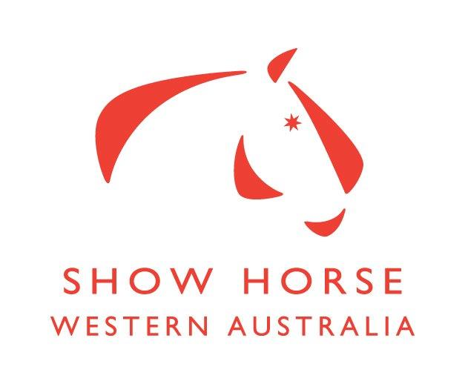

QUALIFYING REQUIREMENTS FOR 2020 HORSE OF THE YEAR

To qualify for the 2020 EWA Horse of the Year Show, a horse/pony must have paid entry fee and competed in at least one class at any official show horse or show hunter class (excluding rider, Owner/Rider & First Ridden classes) at three (3) separate EWA affiliated events (excluding EWA HOY). These must be judged by a current EA Accredited Show Horse Judge. In the event of no placing being awarded, the judge or a club official must sign competition licence as proof of competition.
The horse’s owner and rider must all be current financial members of EWA and horses must hold either a 2019 or a current 2020 EWA Show Horse Competition License at time of qualifying for the event.
All results should be recorded on the Competition License with the name of the presiding judge shown and submitted with entry to HOTY.
Ineligible events:
• Show Horse Council WA Classic
• Show Horse Council WA Western Stars
• Show Horse Council Horse of the Year
• Gosnells Masters
• Any other events not run under EA National Show Horse Rules.
QUALIFYING PERIOD FOR 2020 HORSE OF THE YEAR
IS FROM CLOSE OF ENTRIES 2019 (6th August 2019) until close of entries 2020 (10th August 2020)

HEIGHT CERTIFICATES
Horses and ponies must hold a current EWA Height Certificate on the day of competition.

ALL LEAD REIN HANDLERS MUST BE A CURRENT EWA FINANCIAL MEMBER AT THE TIME OF COMPETITION. THEY MAY BE EITHER PARTICIPANT OR COMPETITOR MEMBER.

HANDLER MUST BE 18 YEARS AND OVER.

RIDERS AGE IS OF 1st JANUARY IN YEAR OF NATIONAL CHAMPIONSHIPS. ADDITIONALLY, RIDERS TURNING 5 YEARS ARE ELIGIBLE TO COMPETE THE DAY THEY TURN 5 YEARS OLD. The age of 5 commences from the child's birthday. The Under 8 age limit is taken as per the child's age as at 1st January in the calendar year that the competition is being held.

Judging at HOY is conducted under the EA Preferential Judging System. Please refer to the EA National Showhorse rules for further details.

2013

2013

HELMETS

Except where Sport Rules allows otherwise, riders and drivers competing in an EA competition, must wear an approved helmet with the chin strap fastened at all times. The same is recommended when riding a horse at any time.

Protective headgear must conform with one of the current approved safety standards:
- Current Australian standard AS/NZS 3838 (2006 onwards) provided they are SAI Global marked.
- New Australian standard ARB HS 2012 provided they are SAI Global marked.
- Current American standard ASTM F1163 (2004a or 04a onwards) provided they are SEI marked.
- Current American standard SNELL E2001.
- Current British standard PAS 015 (1998 or 2011) provided they are BSI Kitemarked.
- Interim European Standard VG1 (01.040: 2014-12) with or without BSI Kitemark.
FOR FURTHER INFORMATION WITH REGARD TO HELMETS PLEASE REFER TO THE EA WEBSITE
http://www.equestrian.org.au/content/current-approved-safety-standards-helmets

Judging Scheme

EWA Judges Accreditation Scheme Rules and Guidelines, are available from www.equestrianwa.org.au > Rules, Regs, Forms > Show Horse.

Updated Judge List is available online http://www.equestrian.org.au/members/search/official

Measuring Scheme
Information relating to Measuring can be found at www.equestrianwa.org.au > Rules, Regs, Forms > Measuring.

All other rules are as per the National Measuring Scheme Rules. www.equestrian.org.au – Rules and Regulations > Measuring

For measuring dates please refer to the EWA website calendar.

Current EWA Measurers are listed at www.equestrianwa.org.au > Searches > Officials, select measuring as criteria.

See National Rules for Permitted Bits

Information for Event Organisers
For an up to date list of Accredited Western Australian Judges, please visit www.equestrian.org.au
2013

National Judges Accreditation Scheme
Please Note: Judges Accreditation Information can be viewed on the Equestrian Australia website. www.equestrian.org.au

Judges
- A link to a list of accredited EWA judges – www.equestrian.org.au -Search – Judges/Officials
- Judges should be provided with a penciller /steward.
- Judges should be provided with suitable meals and ample hot and cold drinks, depending on the weather conditions.
- Morning & Afternoon Tea (15 mins)
- Lunch (30 mins)
- Travel, accommodation and meal expenses if applicable, must be paid by the host club.
- Judges Expenses - It is essential that the matter of reimbursement of expenses be discussed and agreed to prior to the fixture. Suggested reimbursement of Judges as follows: minimum of $75 (depending on distance travelled).

Secure judges well in advance of your event.

** Please notify the EWA Show Horse Committee if your club is experiencing any problems securing Judges.**

Official Dates:
EWA will consult with clubs regarding the date of their fixtures for the following year. These dates, are available on the EWA website. Any qualifying event must use an EWA Official Judge for validity of points and insurance cover.

Results
- Results of all official fixtures are to be forwarded to the EWA office and the RAS within 14 days of the show.

Show Horse Levies
- Please note all $7 levies to be forwarded to the EWA Office within 14 days of the show.
- Levies are used to fund Judge’s education and seminars, and the National Team uniforms.

Protests
- Refer to Protest and Complaints Section in the EWA National Show Horse Rules and Guidelines which is available on the EWA website.

Insurance
- Clubs insured through Equestrian Australia are reminded that all competitors at their events are required to be either EWA Riding Members or direct club members. Direct Club membership covers the member for Public Liability only. Further information relating to Insurance can be found at www.equestrianwa.org.au

Competition Licences
Competition Licences are used to fund swabbing at EWA Show Horse events.

